Title: Study of Analog to Digital Conversion using MATLAB
Abstract
This experiment is conducted to understand how MATLAB can be used to solve basic problems in communication engineering. It helps us learn the process of converting an analog signal into digital form step by step. Through this work, we gain practical knowledge about signal generation, sampling, quantization, and digital encoding, which are important concepts in digital communication.
Theory:
I. Analog to Digital Conversion:
Analog to Digital Conversion (ADC) is the process of converting continuous analog signals into digital data. Digital signals are more reliable and less affected by noise. Common techniques include Pulse Code Modulation (PCM) and Delta Modulation.
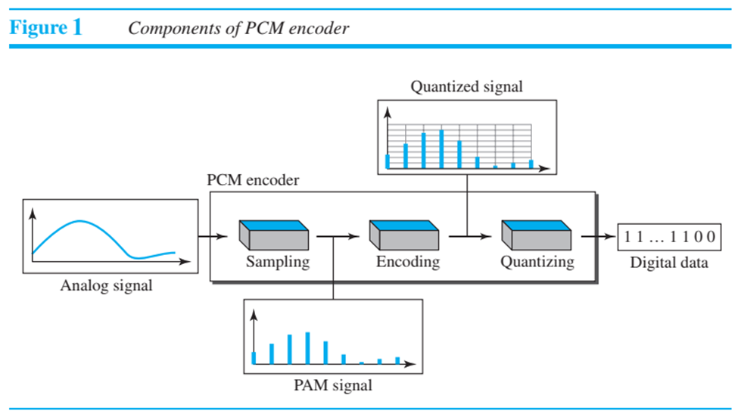
II. Pulse Code Modulation (PCM):
PCM is the most widely used method for converting analog signals into digital form. It involves three main steps:
a) Sampling the analog signal
b) Quantizing the sampled values
c) Encoding them into binary bit stream
III. Sampling:
Sampling is the first step in PCM where the analog signal is measured at regular intervals $T_{s}$. The sampling frequency is given by $f_{s}=\frac{1}{T_{s}}$. Common sampling methods include ideal, natural, and flat-top sampling.
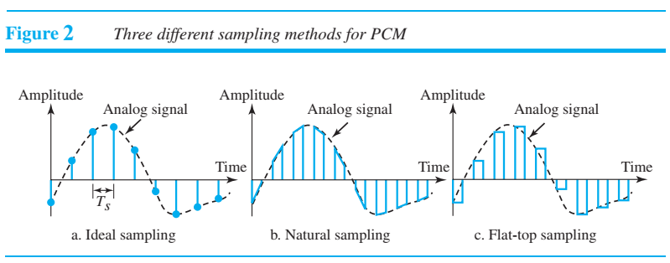
Sampling Methods:
In ideal sampling, exact values of the analog signal are taken, but it is not practical to implement. In natural sampling, a switch samples the signal for a short duration, preserving its shape. The most common method is sample-and-hold, which produces flat-top samples. This process is also known as Pulse Amplitude Modulation (PAM). According to the Nyquist theorem:
$$f_{s}≥2f_{max}$$

Quantization:
Quantization converts sampled values into discrete levels. The signal range between $V_{min}$and $V_{max}$is divided into $L$levels with step size:
$$Δ=\frac{V_{max}-V_{min}}{L}$$
Each sample is approximated to the nearest level. For example, if the range is −20 V to +20 V and $L=8$, then $Δ=5 V$.

Quantization Levels:
The number of levels $L$depends on the signal range and the required accuracy. More levels provide better signal representation.

Quantization Error:
Quantization introduces error, which affects signal quality. The Signal-to-Noise Ratio (SNR) is given by:
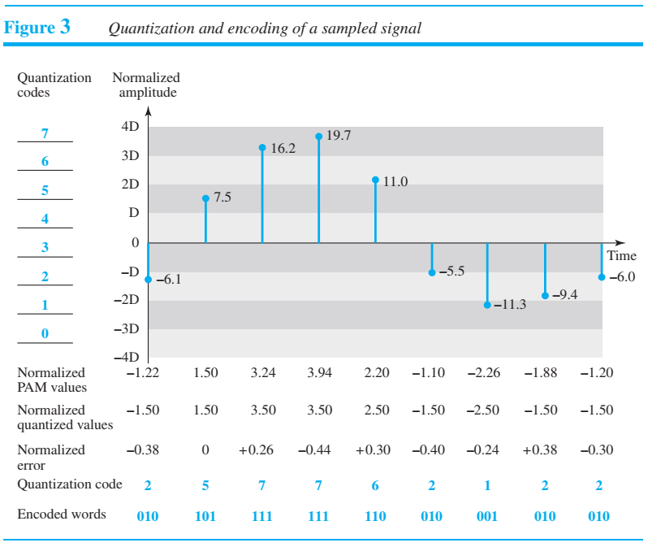
$$SNR_{dB}=6.02n_{b}+1.76$$
Quantization in MATLAB:
A simple quantization method in MATLAB uses the input signal $x$and number of levels $L$. The step size is:
$$Δ=\frac{x_{max}-x_{min}}{L-1}$$
The quantized signal is calculated as:
$$x_{q}=x_{min}+round\left(\frac{x-x_{min}}{Δ}\right)×Δ$$
Here, $x_{max}$and $x_{min}$are the maximum and minimum values of the signal, $L$is the number of levels, and $Δ$is the step size.

Encoding:
Encoding is the final step where quantized samples are converted into binary form. The number of bits per sample is:
$$n_{b}={log⁡}_{2}(L)$$
The index for encoding is:
$$i=round\left(\frac{x-x_{min}}{Δ}\right)$$
The bit rate is given by:
$$BR=f_{s}×n_{b}$$clc
clear all
close all

%%%%%%%%%%%%%%%%%%%%%%%%%%%%%%%
% Analog to Digital Conversion
%%%%%%%%%%%%%%%%%%%%%%%%%%%%%%%

time_duration = 0.2;

%% Analog-like signal's representation
% Analog signal generation is not possible in MATLAB
a = [0.4 0.6 0.8]; % amplitude array for composite signal
f = [5 12 20]; % frequency array for composite signal

analog_t = 0:0.0001:time_duration;
analog_sig = a(1)*sin(2*pi*f(1)*analog_t) + a(2)*cos(2*pi*f(2)*analog_t) + a(3)*sin(2*pi*f(3)*analog_t + pi/4);

figure
subplot(1,2,1)
plot(analog_t, analog_sig,'linewidth',1.5)
grid on
xlabel('time in seconds')
ylabel('amplitude in volts')
title('analog signal')

%% Sampling Frequency
fs = 250;
ts = 1/fs;

%% Sampling
samp_t = 0:1/fs:time_duration;
samp_sig = a(1)*sin(2*pi*f(1)*samp_t) + a(2)*cos(2*pi*f(2)*samp_t) + a(3)*sin(2*pi*f(3)*samp_t + pi/4);

subplot(1,2,2)
plot(samp_t, samp_sig,'o','linewidth',1.5)
grid on
xlabel('time in seconds')
ylabel('amplitude in volts')
title(['sampled signal for ',num2str(fs),' Hz sampling frequency'])

%% Levels for Quantization
L = 8;

%% Quantizing
delta = (max(samp_sig) - min(samp_sig))/(L-1); % step size
quant_sig = min(samp_sig) + round((samp_sig-min(samp_sig))/delta)*delta; % quantized signal

figure
subplot(1,2,1)
plot(samp_t, samp_sig,'o','linewidth',1.5)
grid on
xlabel('time in seconds')
ylabel('amplitude in volts')
title('sampled signal')

subplot(1,2,2)
plot(samp_t, quant_sig,'x','linewidth',1.5);
xlabel('time')
ylabel('amplitude')
title('quantized samples')

%% Number of Bits/Sample
nb = log2(L);

%% Encoding
i = round((samp_sig-min(samp_sig))/delta); % index for encoding
dig_data_matrix = de2bi(i,nb); % encoded binary bits are as a matrix here
dig_data = reshape(dig_data_matrix',1,[]); % encoded binary bits are as an array here
disp(['The index values for encoding from quantization of the sampled signal are: ',num2str(i)])
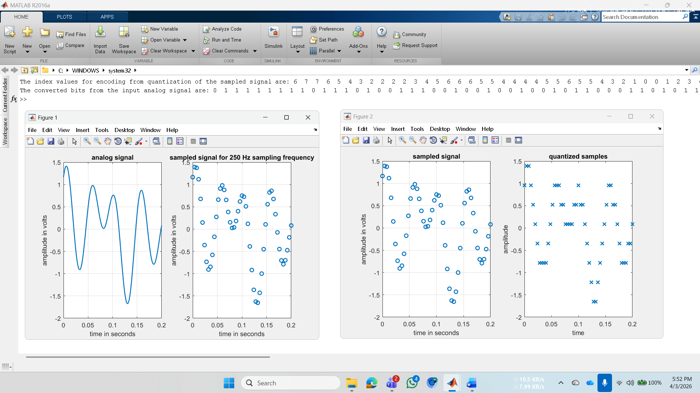
disp(['The converted bits from the input analog signal are: ',num2str(dig_data)])

Output for Encoding:
The index values for encoding from quantization of the sampled signal are: 6 7 7 6 5 4 3 2 2 2 2 3 4 5 6 6 6 5 5 4 4 4 4 5 5 6 5 5 4 3 2 1 0 0 1 2 3 4 5 6 6 5 5 4 3 2 2 2 3 3 4

The converted bits from the input analog signal are: 0 1 1 1 1 1 1 1 1 0 1 1 1 0 1 0 0 1 1 1 0 0 1 0 0 1 0 0 1 0 0 1 0 1 1 0 0 0 1 1 0 1 0 1 1 0 1 1 0 1 1 1 0 1 1 0 1 0 0 1 0 0 1 0 0 1 0 0 1 1 0 1 1 0 1 0 1 1 1 0 1 1 0 1 0 0 1 1 1 0 0 1 0 1 0 0 0 0 0 0 0 0 1 0 0 0 1 0 1 1 0 0 0 1 1 0 1 0 1 1 0 1 1 1 0 1 1 0 1 0 0 1 1 1 0 0 1 0 0 1 0 0 1 0 1 1 0 1 1 0 0 0 1

Performance Task:
clc
clear all
close all

% Analog to Digital Conversion

time_duration = 0.2;

%% Parameters from ID
a1 = 6; a2 = 8; a3 = 7; a4 = 9;
f1 = 10; f2 = 12; f3 = 6; f4 = 7;

%% Analog Signal
analog_t = 0:0.0001:time_duration;

analog_sig = a1*sin(2*pi*f1*analog_t) + ...
a2*cos(2*pi*f2*analog_t) + ...
a3*sin(2*pi*f3*analog_t) + ...
a4*sin(2*pi*f4*analog_t);

figure
subplot(1,2,1)
plot(analog_t, analog_sig,'linewidth',1.5)
grid on
xlabel('time (s)')
ylabel('amplitude')
title('Analog Signal')

%% Sampling Frequency (from part c)
fs = 150; % chosen based on bandwidth
ts = 1/fs;

%% Sampling
samp_t = 0:ts:time_duration;

samp_sig = a1*sin(2*pi*f1*samp_t) + ...
a2*cos(2*pi*f2*samp_t) + ...
a3*sin(2*pi*f3*samp_t) + ...
a4*sin(2*pi*f4*samp_t);

subplot(1,2,2)
stem(samp_t, samp_sig,'filled')
grid on
xlabel('time (s)')
ylabel('amplitude')
title(['Sampled Signal (fs = ',num2str(fs),' Hz)'])

%% Quantization Levels (from SNR)
L = 32; % calculated below

delta = (max(samp_sig) - min(samp_sig))/(L-1);

quant_sig = min(samp_sig) + ...
round((samp_sig - min(samp_sig))/delta)*delta;

figure
subplot(1,2,1)
stem(samp_t, samp_sig,'filled')
title('Sampled Signal')
grid on

subplot(1,2,2)
stem(samp_t, quant_sig,'r','filled')
title('Quantized Signal')
grid on

%% Number of bits
nb = log2(L);

%% Encoding
i = round((samp_sig - min(samp_sig))/delta);

dig_data_matrix = de2bi(i, nb);
dig_data = reshape(dig_data_matrix',1,[]);

disp('Index values:')
disp(i)

disp('Digital Data (bit stream):')
disp(dig_data)

a) Show analog signal, sampled signal, and quantized signal.
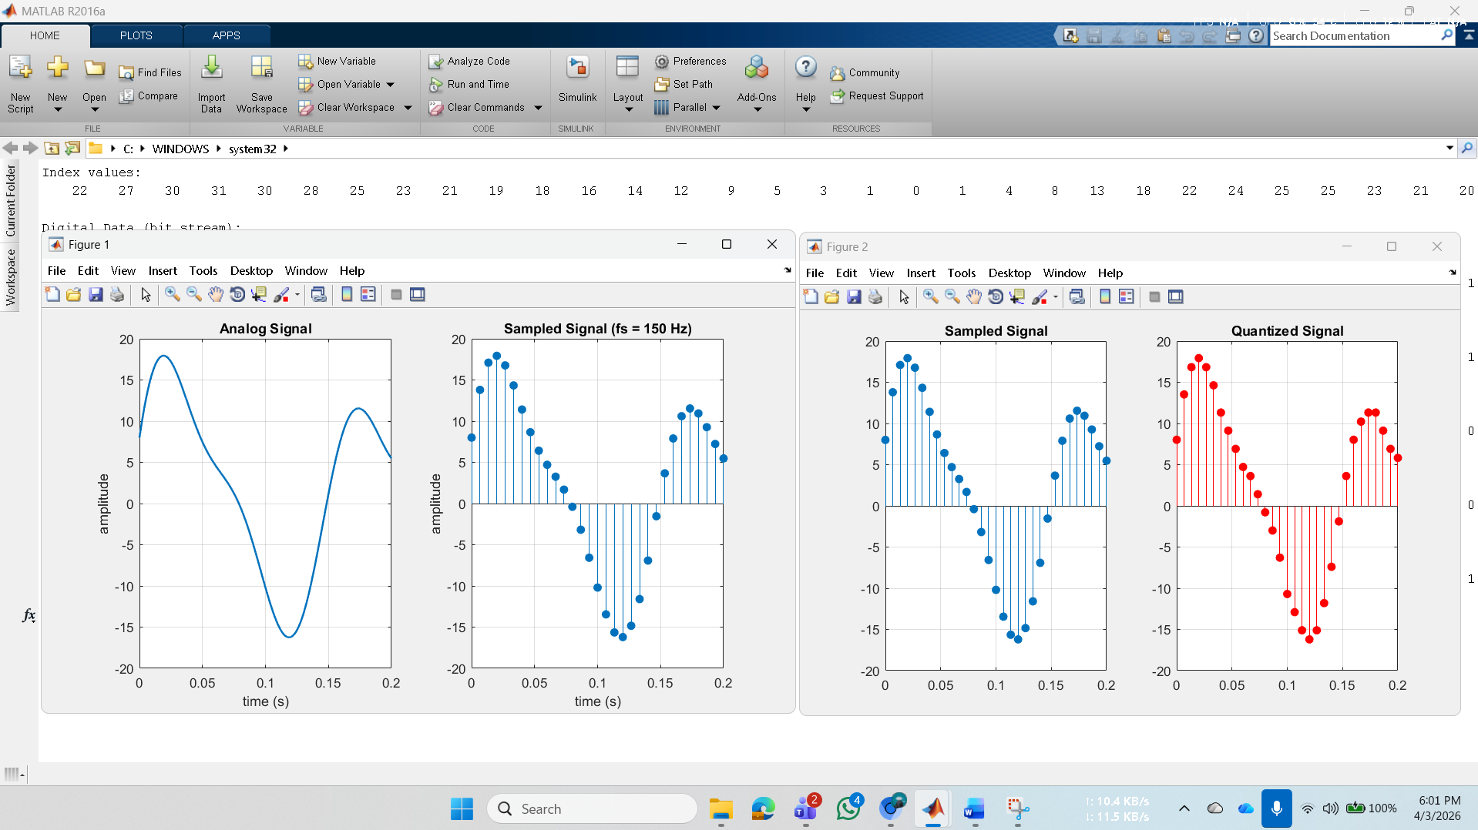

b) Show the digital data from the analog signal.
Index values:
22 27 30 31 30 28 25 23 21 19 18 16 14 12 9 5 3 1 0 1 4 8 13 18 22 24 25 25 23 21 20

Digital Data (bit stream):
Columns 1 through 31
0 1 1 0 1 1 1 0 1 1 0 1 1 1 1 1 1 1 1 1 0 1 1 1 1 0 0 1 1 1 1

Columns 32 through 62
0 0 1 1 1 1 1 0 1 1 0 1 0 1 1 1 0 0 1 0 1 0 0 1 0 0 0 0 1 0 1

Columns 63 through 93
1 1 0 0 0 1 1 0 1 0 0 1 0 1 0 1 0 0 1 1 0 0 0 1 0 0 0 0 0 0 0

Columns 94 through 124
0 0 1 0 0 0 0 0 0 1 0 0 0 0 0 1 0 1 0 1 1 0 0 1 0 0 1 0 1 1 0

Columns 125 through 155
1 0 0 0 1 1 1 0 0 1 1 1 0 0 1 1 1 1 1 0 1 1 0 1 0 1 0 0 1 0 1

c) What are the appropriate values of sampling frequency and number of levels of quantization if minimum required SNR and bandwidth of the channel are 25 dB and 150 Hz respectively.
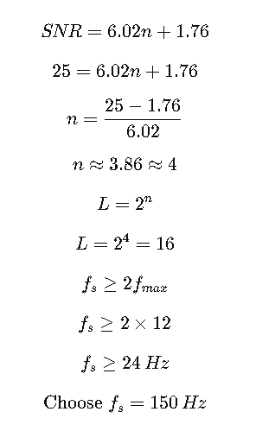

Discussion
In this experiment, we implemented the process of Analog-to-Digital Conversion (ADC) using MATLAB and examined each stage in detail. The analog signal was first sampled, where the importance of selecting an appropriate sampling frequency based on the Nyquist criterion was observed. Next, during quantization, we noticed that increasing the number of levels reduces quantization error and improves signal quality. Finally, the encoding process converted the quantized values into binary data for digital transmission. The experiment highlighted how each step affects the overall accuracy and efficiency of the system, helping us better understand the practical aspects of digital communication.

Conclusion
In this experiment, we successfully implemented and analyzed the process of Analog-to-Digital Conversion (ADC) using MATLAB. We explored key concepts such as sampling, quantization, and encoding, which are essential for digital communication systems. The results demonstrated the importance of selecting an appropriate sampling rate and quantization levels to achieve a balance between signal accuracy and transmission efficiency. Understanding these concepts is fundamental for designing reliable digital communication and signal processing systems.

